Raspberry Pi resistor value for LED calculation

Suppose we have the following circuit on the Raspberry Pi:

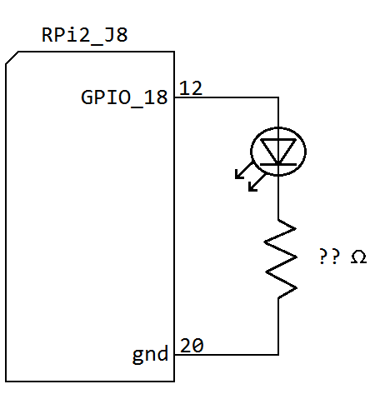

The question is what should we use for the resistor value? Consider the following rules of thumb:

-The voltage drop across a typical silicon P-N junction, for example in a LED, is 0.6 V to 0.7 V, to average this out

let's use 0.65 V drop across the LED

-The RPi GPIO pins provide 3.3 V

-The RPi GPIO pins should never be used to source more than 16 mA per pin and never more than 50 mA total, it

would be recommended to never get even close to the 16 mA per pin

So now we can figure the voltage drop across the resistor is 2.65 V as follows:

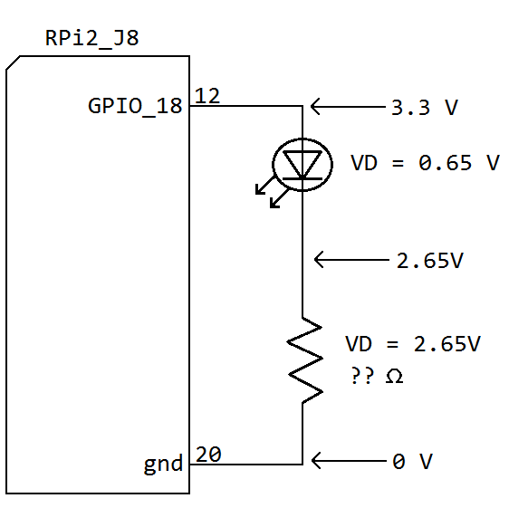

Remembering our basic formula for voltage, current, and resistance (Ohm's law):

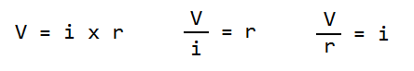

Suppose we were to use a 330 ohm, 470 ohm, or 1k ohm resistor:

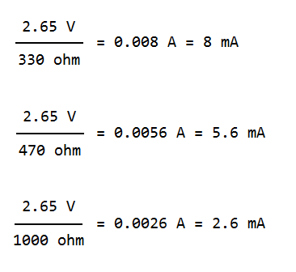

Comparing the currents to the rules of thumb listed above, any of these resistor values would be ok. Note that the 330 ohm value should not be used if you have many resistors/LEDs connected as this would eventually push or exceed the 50 mA source current max for the RPi. Also, the 1k ohm resistor @ 2.6 mA may not be enough current to noticeably light some LEDs.

For these reasons I considered 470 ohm to be a good middle ground resistor value to use for this tutorial. In any case it would NOT be recommended to use a resistor value less than 330 ohms, I've seen tutorials with resistor values for an equivalent circuit of 220 ohms or even 100 ohms, such low values could damage your RPi and would not be a good idea.

A final note, the above calculations are based on things being "ideal" which of course in an actual circuit they are not, in practice if you assemble the circuit in the tutorial and take measurements matching the above your measurements will be at least slightly different. However, the above is at least enough of an estimate to base your resistor value choice on.